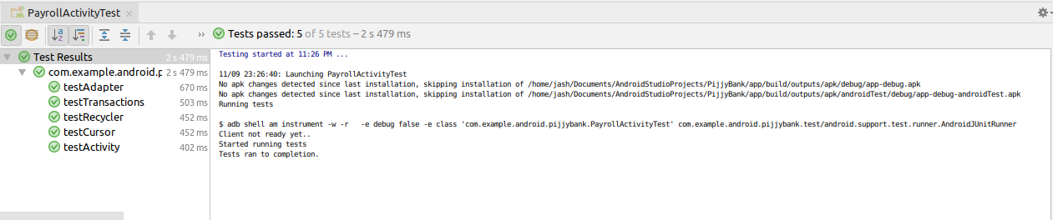

**package** com.example.android.pijjybank;

**import** android.content.pm.ActivityInfo;

**import** android.support.test.rule.ActivityTestRule;

**import** android.view.View;

**import** android.widget.LinearLayout;

**import** org.junit.After;

**import** org.junit.Before;

**import** org.junit.Rule;

**import** org.junit.Test;

**import static** junit.framework.Assert.*assertEquals*;

**import static** junit.framework.Assert.*assertNotNull*;

**public class** PayrollActivityTest {

@Rule

**public** ActivityTestRule<PayrollActivity> **mActivityTestRule** = **new** ActivityTestRule<PayrollActivity>(PayrollActivity.**class**);

**private** PayrollActivity **pact** = **null**;

@Before

**public void** setUp() **throws** Exception {

**pact** = **mActivityTestRule**.getActivity();

}

@Test

**public void** testActivity(){

LinearLayout toolbar = (LinearLayout)**pact**.findViewById(R.id.***zeroTransactions***);

*assertNotNull*(toolbar);

}

@Test

**public void** testTransactions(){

*assertNotNull*(**pact**.**transactionList**);

}

@Test

**public void** testRecycler(){

View view = **pact**.findViewById(R.id.***recyclerView***);

*assertNotNull*(view);

}

@Test

**public void** testAdapter(){

*assertNotNull*(**pact**.**expenseAdapter**);

}

@Test

**public void** testCursor(){

**int** orientation;

orientation = **pact**.getRequestedOrientation();

*assertEquals*(ActivityInfo.***SCREEN_ORIENTATION_UNSPECIFIED***,orientation);

}

@After

**public void** tearDown() **throws** Exception {

**pact** = **null**;

}

}